

PI Revenue User Documentation

Version 1.0

October, 2017

The PI Revenue application is a web application used to Import and process revenue information. This application is written in asp.net, c# using the PI Corporate SQL database.

The purpose of this application is to replace the existing Revenue Access database for revenue import and processing and provide an interface for importing Beacon, New World, Other Revenue, Accruals and Adjustments, and produce management and sales reports.

Contents

GETTING STARTED 3

SYSTEM COMPONENTS 3

LOGIN 4

HOME DASHBOARD 5

SEARCH 7

EXPORTING TO EXCEL 8

IMPORT 9

Before Importing Revenue, Prepare the Data 10

Check for New Accounts in PIContracts 10

Import Data 10

HISTORY 11

MAINTENANCE 12

USER LOGINS 13

REPORTS 14

# GETTING STARTED

The PI Revenue web application has been optimized for the Chrome browser.

**URL**:

http://picer-dev-app01:90/PIRevenue/

**USER ACCESS:**

Each user must be given access by the system administrators. For access, contact the IT Administrator: [app.support@purolatorintl.com](mailto:app.support@purolatorintl.com)

**USER ROLES:**

The roles established for the PI Revenue Web system are:

* Data Entry – Detailed search functions, importing of all data types, and all reporting functions.
* Admin – Detailed search functions, importing of all data types, and all reporting functions, plus table maintenance and user administration.
* Sales – Access to reports restricted by user access to region or district.
* Audit – Allows running of reports and archived data export, but no data modification or importing.
* ITAdmin – includes all admin functions, plus rollback of data import.

# SYSTEM COMPONENTS

The system components available via the menu tabs are:

* Home Dashboard
* Search
  + Revenue Analysis
  + Review Weekly GL Imports
  + View List of Imports by Week
  + Act Plan Account Detail
  + Monthly Accrual Reversal Query
  + Account Realignment Query
  + Monthly Cost Center Detail
  + Weekly Trend RPS
  + Query Check Analysis
* Import
  + Import Revenue
  + Import Budget
* History
  + Export Archived Revenue by Fiscal Month
  + Export Archived Weekly GL Imports
* Maintenance
  + ROE Lookup & Maintenance
  + Product Maintenance
  + Product Group Maintenance
  + Accessorial Maintenance
  + Revenue Grouping Maintenance
  + Fiscal Year Maintenance
  + User Logins (for admin users)
  + User Region Restrictions
  + User District Restrictions
* Reports
  + Act Plan Report
  + Cross Tab Report
  + Weekly Trader Detail
  + Weekly Trader Summary
  + Weekly Revenue Trend
  + Weekly Revenue Trend Detail
  + Monthly Trader Detail
  + Monthly Trader Summary
  + Monthly Revenue Trend
  + Monthly Revenue Trend Detail
  + Custom Weekly Trader
  + Adaptive Monthly
  + Adaptive Range
  + Revenue by Service Month

# LOGIN

Login using your Windows Login and Password. You must be given access to the PI Revenue system to obtain access. Contact [app.support@purolatorintl.com](mailto:app.support@purolatorintl.com) for all access requests.

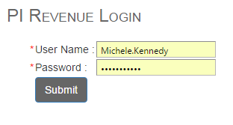

*NOTE: You will be redirected to the login screen if your session times out after a period of inactivity.*

# HOME DASHBOARD

The dashboard gives an overall view of the revenue using charts and totals.

The home page of the PI Revenue Web application is the *Dashboard*. The Dashboard gives you an overview of the revenue data by showing you totals and charts.

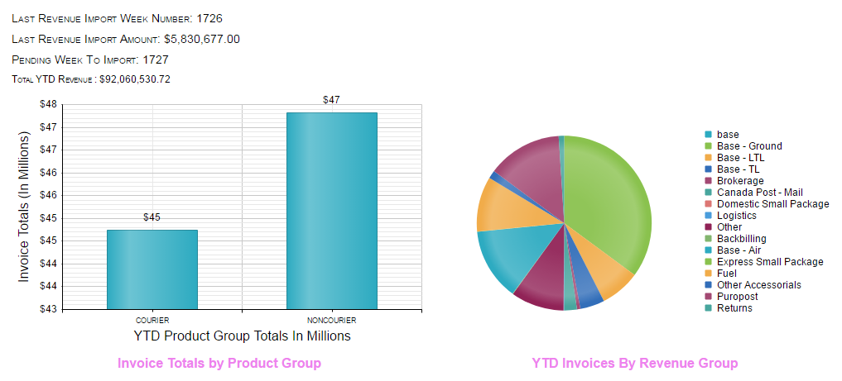

Stats regarding the last week imported are displayed.

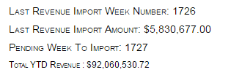

A bar chart shows statistics regarding the YTD revenue broken out by Product Group

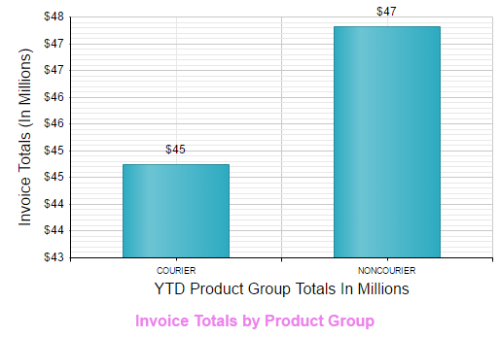

The Pie Chart displays totals by Revenue Group.

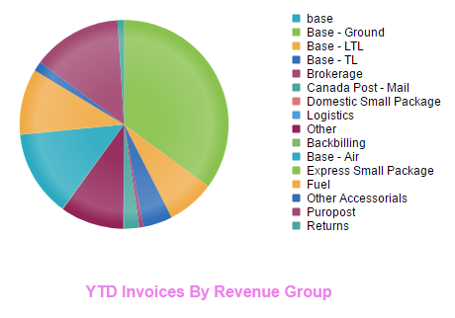

A grid displays the most recently imported invoices.

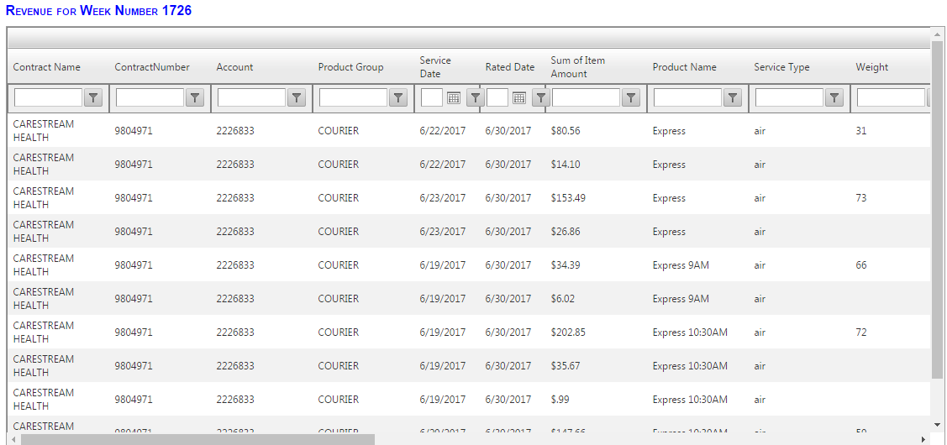

# SEARCH

Use any of the search functions to search for data and display the results on screen in a data grid. The data in any data grid can be exported to Excel.

# EXPORTING TO EXCEL

At any time you may export the data displayed in the data grid to Excel by clicking the Excel icon in upper right hand corner of the data grid.

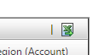

REVENUE ANALYSIS

Use the Revenue Analysis Search to view the summarized revenue for any date range.

REVIEW WEEKLY GL IMPORTS

Use the Review Weekly GL Imports to view the raw data that was imported.

VIEW LIST OF IMPORTS BY WEEK

View List of Imports by Week shows a listing of all imports done for a given week number.

ACT PLAN ACCOUNT DETAIL

The Act Plan Account Detail shows the Act Plan data detail, with information broken out by account.

MONTLY ACCRUAL REVERSAL QUERY

The Monthly Accrual Reversal shows the accrual reversal needed to reverse the prior month’s accrual. The Rated Date is usually the last day of the prior month and the Fiscal Month would be the current fiscal month.

ACCOUNT REALIGNMENT QUERY

The Account Realignment Query shows accounts that are missing Airport, Cost Center, District or Relationship Name with total associated revenue.

MONTLY COST CENTER DETAIL

The Monthly Cost Center Detail shows revenue totals by Cost Center.

WEEKLY TREND RPS

The Weekly Trend RPS shows revenue summary for Courier for a specified week number.

QUERY CHECK ANALYSIS

The Query Check Analysis shows revenue summary with a rated date greater than or equal to the selected date.

# IMPORT

IMPORT REVENUE

The Import Revenue function takes an Excel file in the proper layout, parses and validates the data and displays the data for final review before importing.

Choose the type of revenue you wish to import, and navigate to select the Excel file to import.

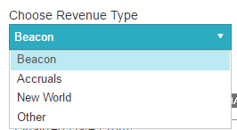

When importing Beacon revenue, enter the dates included in the import. 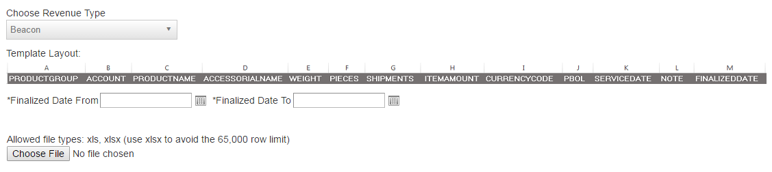

A check of the file will be performed to ensure that each date within the selected date range is included in the import file. The system will issue a warning if any dates are found that do not contain revenue rows.



When selecting any revenue type other than Beacon, the date range is not required.

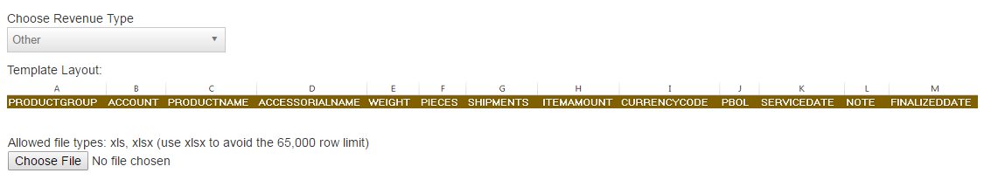

## Before Importing Revenue, Prepare the Data

Create a copy of the blank import template

Copy Data into the template, making sure to replace ProductName and AccessorialName with ProdImport and AccessImport

Use the Note field column that is populated with data

The following columns should be copied as-is: ProductGroup, Account, Weight, Pieces, Shipments, ItemAmount, Currency, PBOL, ServiceDate, FinallizedDate

## Check for New Accounts in PIContracts

Copy the Accounts column to a new spreadsheet

Remove duplicate rows via Data > Remove Duplicates (Copying the accounts and removing duplicates cuts time down from several minutes to a matter of seconds)

Save the spreadsheet

There is an Account check in the PI Contracts system (http://picer-prd-app01:90/PIContracts/)

Run the Account Check via Account Utilities > Account Check

New accounts are identified – make sure these accounts are added before doing the import

## Import Data

In PI Revenue system, Import via Import > Import Revenue

Select the Revenue Type – Beacon, Accruals or New World

For Beacon imports, the entire week can be imported in one Excel spreadsheet.

Select the week beginning date and the week ending date.

If any dates between the start date and end date are not included in the Beacon import file, a message will be displayed.

When the data has been processed, a browser will pop up with the import data for final review before import.

Click the *Do Import* button to complete the import.

The progress bars indicate that the process is running.

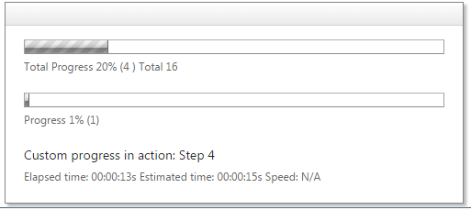

IMPORT BUDGET

Use the Budget Template to load data into the budget table. The table, *tblRevenueBudget* will be cleared of existing data, and data from the Excel file will be loaded.

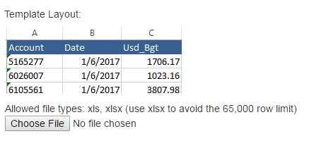

# HISTORY

Data in the Revenue database older than two years will be archived. You can export this data to Excel by GL Import or by Revenue Summary data.

EXPORT ARCHIVED REVENUE BY FISCAL MONTH

Summarized revenue by fiscal month older than two years can be exported to Excel. Select the beginning and ending Rated Dates.

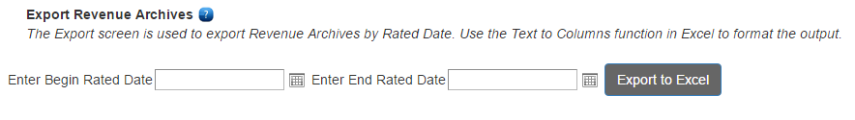

EXPORT ARCHIVED WEEKLY GL IMPORTS

Weekly GL Imports older than two years can be exported to Excel. Select the beginning and ending Rated Dates.

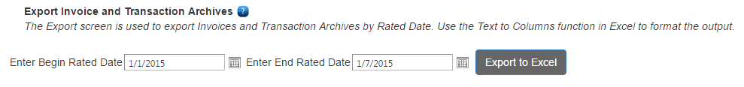

# MAINTENANCE

Use the maintenance screens to maintain tables used in revenue reporting. To initiate a new record, use the *Add new record* icon is the upper left of the grid.



To edit an existing record, use the edit icon.



ROE LOOKUP AND MAINTENANCE

View the Rate of Exchange for any date, and add the Rate of Exchange for any date that is missing.

PRODUCT MAINTENANCE

Enter and maintain Product Codes.

PRODUCT GROUP MAINTENANCE

Enter and maintain Product Group Codes.

ACCESSORIAL MAINTENANCE

Enter and maintain Accessorials.

REVENUE GROUPING MAINTENANCE

Enter and maintain Revenue Groupings.

FISCAL YEAR MAINTENANCE

Use the Fiscal Year Template to load data into the fiscal year table. The table, *tblFiscalYear* will be cleared of existing data, and data from the Excel file will be loaded.

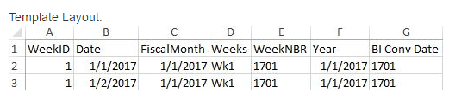

## USER LOGINS

Users who are given the *Admin* access level will have the ability to add users. Select the user from the list of Purolator Employees and assign a user role. If the Purolator employee does not appear in the list of users, contact IT app support.

Users who need to be restricted to just one region or district are first assigned a user login, then restricted to the region or district using the User Region Restriction function or the User District Restriction function.

Any user who is not restricted to a particular region or restricted will have access to all regions and districts.

USER REGION RESTRICTIONS

To restrict a user to a region, the user must first be set up with a login. Select the user from the list of PI Revenue users, then select the region that the user will have access to.

Region restrictions will allow a user to select only their region on all reports.

Use the delete icon to remove the restriction for a user.



Note: removing a region restriction will return the user to default status, which gives the user access to all regions.

USER DISTRICT RESTRICTIONS

To restrict a user to a district, the user must first be set up with a login. Select the user from the list of PI Revenue users, then select the district that the user will have access to.

District restrictions will allow a user to select only their district on all reports.

Use the delete icon to remove the restriction for a user.



Note: removing a district restriction will return the user to default status, which gives the user access to all districts.

# REPORTS

Each report has an option to view the report onscreen, and an Export to Excel option. The View button will display the report onscreen.

Each onscreen report has a menu bar with the options to page forward and backward, Find and Export.



The Export options are Excel, PDF and Word.

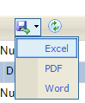

Click the Save icon to export to Excel, then look for the Excel File to appear in the lower left corner.

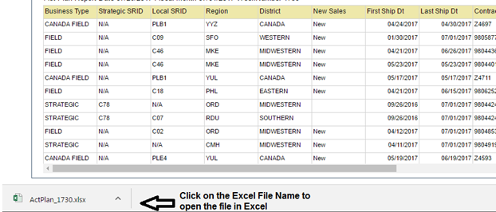



The Export to Excel option will export the report data directory to Excel without showing it on the screen. The Excel filename will appear in the lower left corner.



ACT PLAN REPORT

Exports several tabs of information for Week, Month and YTD Revenue details by Contract as compared to prior year.

CROSS TAB REPORT

Revenue totals by Relationship Name

WEEKLY TRADER DETAIL

Revenue data broken down by Week for Prior Year and Current Year by Relationship Name broken down by Region. Does not include monthly accruals.

WEEKLY TRADER SUMMARY

Revenue data broken down by Week for Prior Year and Current Year by Relationship Name. Does not include monthly accruals.

WEEKLY REVENUE TREND

Revenue data broken out by Week Number including all weeks from prior year and current year.

Does not include monthly accruals.

WEEKLY REVENUE TREND DETAIL

Detailed revenue data with account detail broken out by Week Number including all weeks from prior year and current year. Does not include monthly accruals.

MONTHLY TRADER DETAIL

Revenue data broken down by Week for Prior Year and Current Year by Relationship Name broken down by Region. Includes monthly accruals.

MONTHLY TRADER SUMMARY

Revenue data broken down by Week for Prior Year and Current Year by Relationship Name. Includes monthly accruals.

MONTHLY REVENUE TREND

Revenue data broken out by Week Number including all weeks from prior year and current year. Includes monthly accruals.

MONTHLY REVENUE TREND DETAIL

Detailed revenue data with account detail broken out by Week Number including all weeks from prior year and current year. Includes monthly accruals.

CUSTOM WEEKLY TRADER

The Custom Trader Report allows you to run a Trader Report with your choice of date fields to base your selection on, and also specify custom *from* and *to* dates. Select from *Finalized Date*, *Service Date* and *Fiscal Month* to use as date selection criteria.

ADAPTIVE MONTHLY

Revenue data details with corresponding Adaptive Names.

ADAPTIVE RANGE

Revenue data details with corresponding Adaptive Names for the selected date range.

SERVICE BY REVENUE MONTH

Revenue data summarized by Contract and Account selected by choice of finalized date or fiscal month.